**Answer to the Question No 1(a)**

ls

cd Downloads

cat>18201178_1.txt

cat>18201178_2.txt

cat>18201178_3.txt

cat>18201178_4.txt

mkdir samiul1

mkdir samiul2

mv 18201178_1.txt 18201178_2.txt 18201178_3.txt samiul1

mkdir samiul3

cp -r samiul1 samiul3

cd samiul3

ls-l

chmod g+rx-w ./*

chmod o+rx-w ./*

cd ..

ls-l

rm -rf ./*  
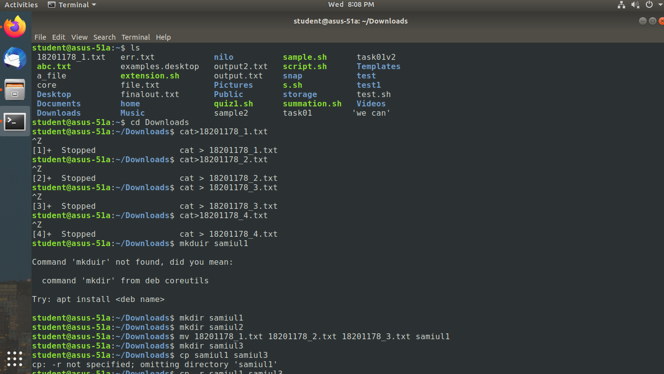

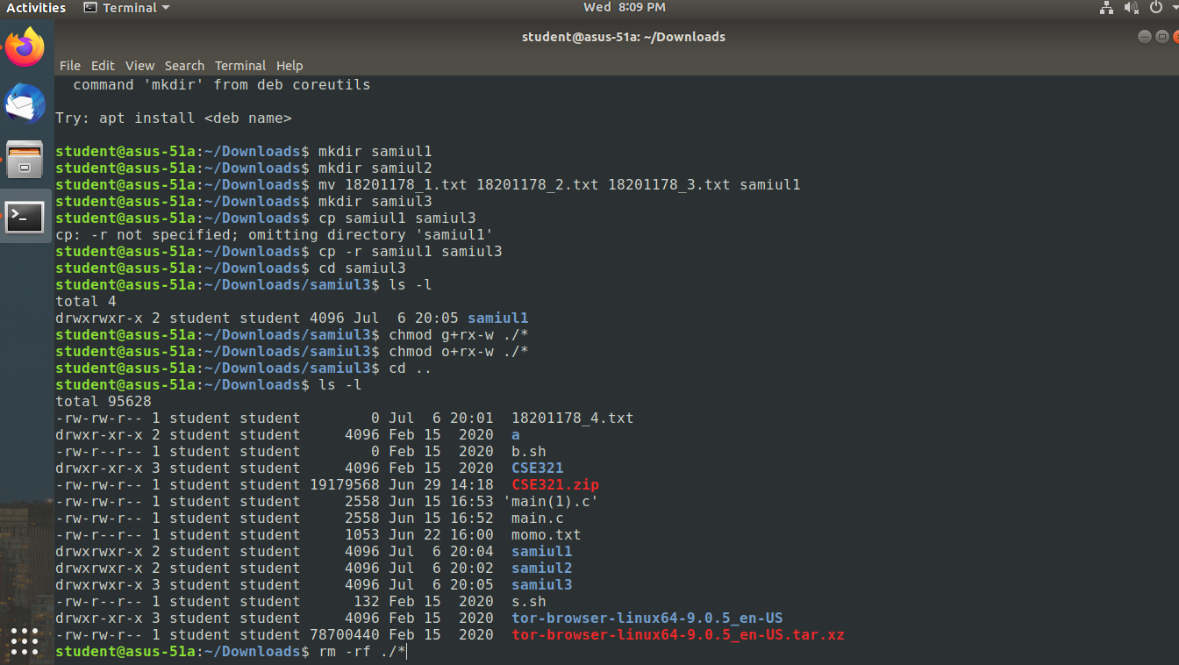

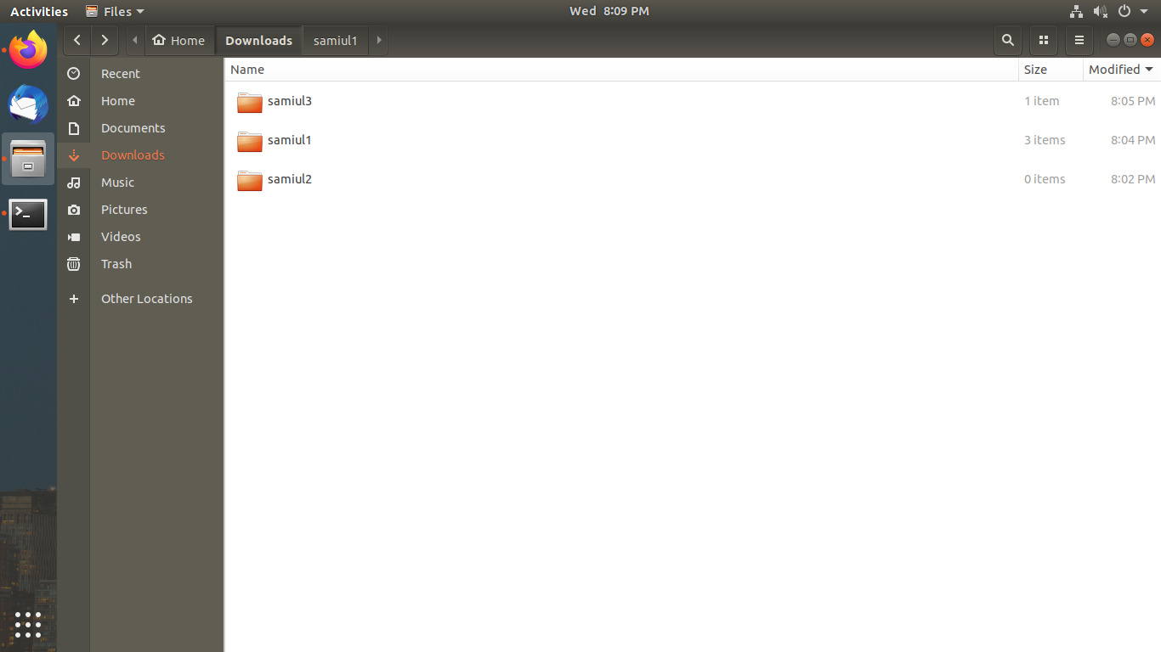

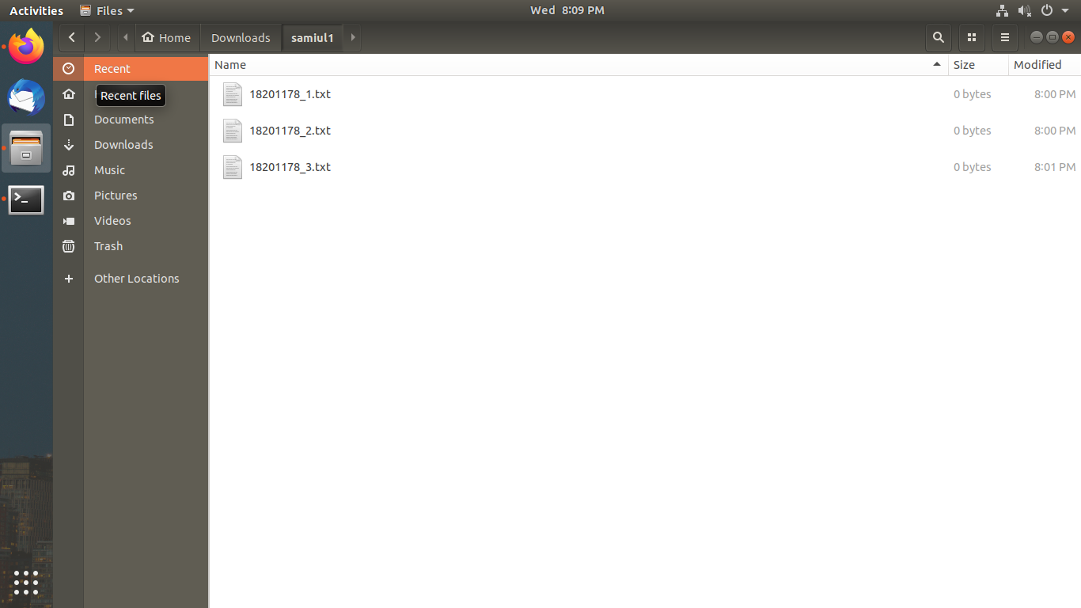

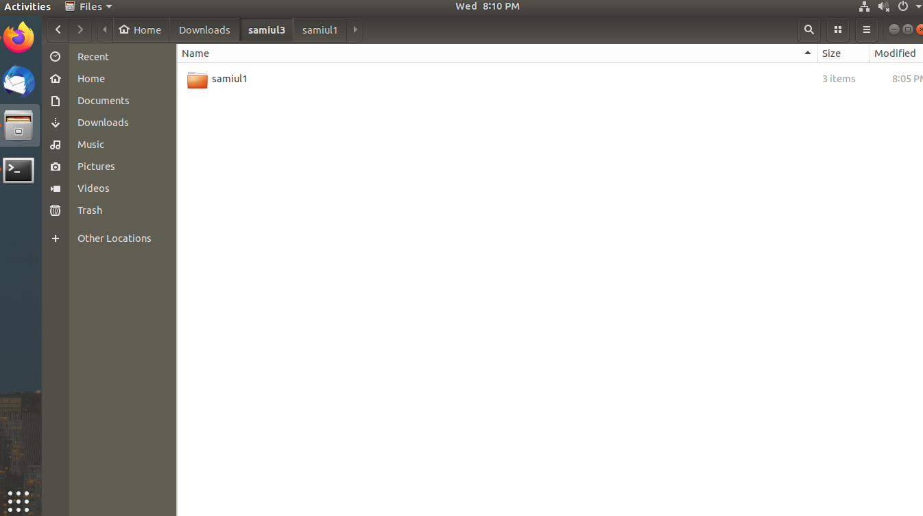

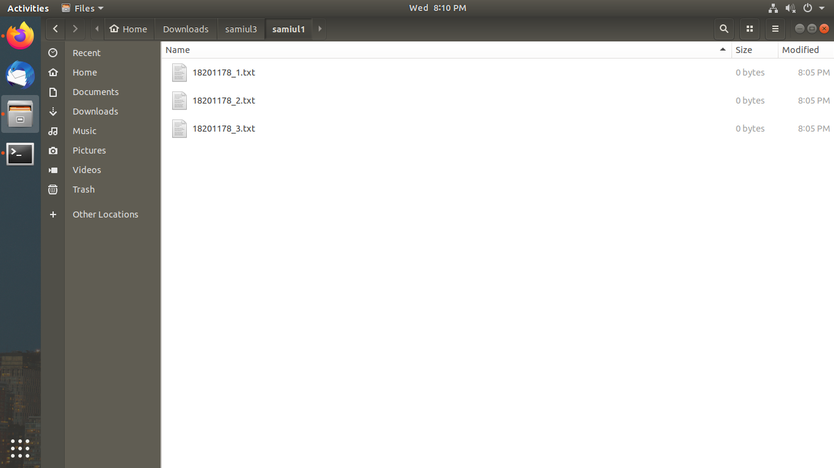

**Answer to the Question No 1(b)**

$grep -o CSE course.txt |wc -l

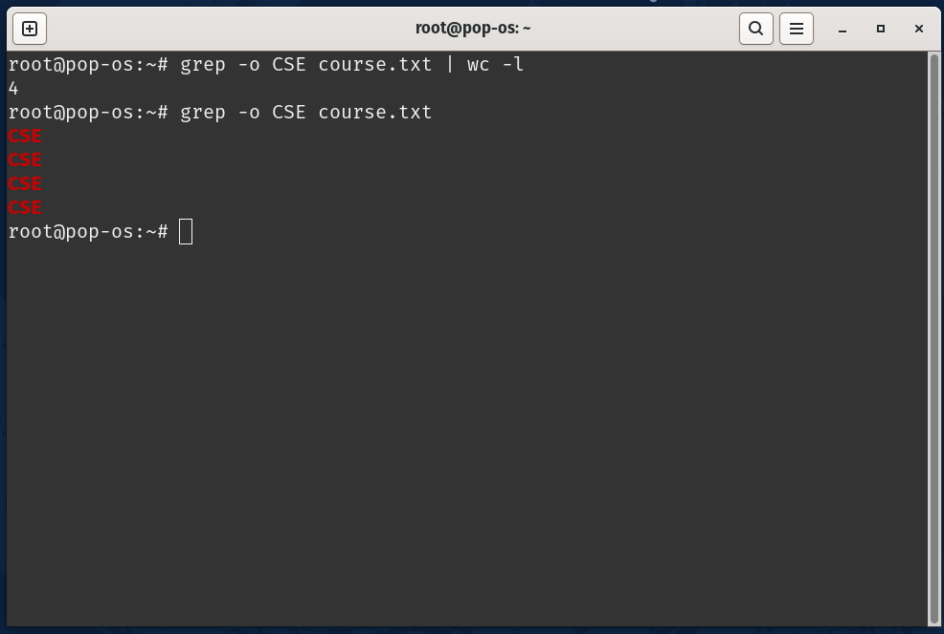

**Answer to the Question No 1(c)**

$ls-l

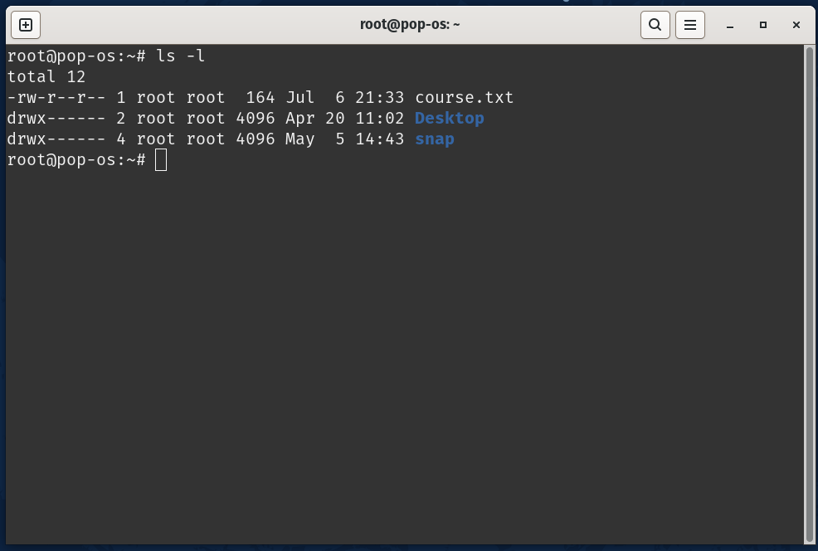

**Answer to the Question No 1(d)**

$head -17 line.txt| tail -5

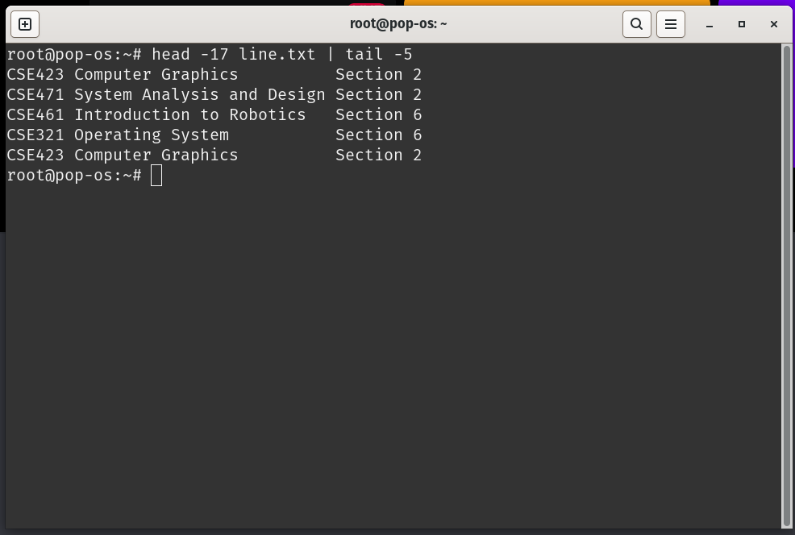

**Answer to the Question No 2(a)**

#include<stdio.h>

#include<conio.h>

void sub(int a,int b){

int c = a-b;

printf("Sub Result : %d ",c);

}

void add(int a,int b){

int c = a+b;

printf("Add Result : %d ",c);

}

void mul(int a,int b){

int c = a*b;

printf("Mul Result : %d ",c);

}

int main()

{

int a,b,d;

char op;

printf("Enter numbers: ");

scanf("%d%d%d",&a,&b,&d);

if (a > b){

sub(a,b);

}

if (a < b){

add(a,b);

}

if (d == b){

mul(b,d);

}

}

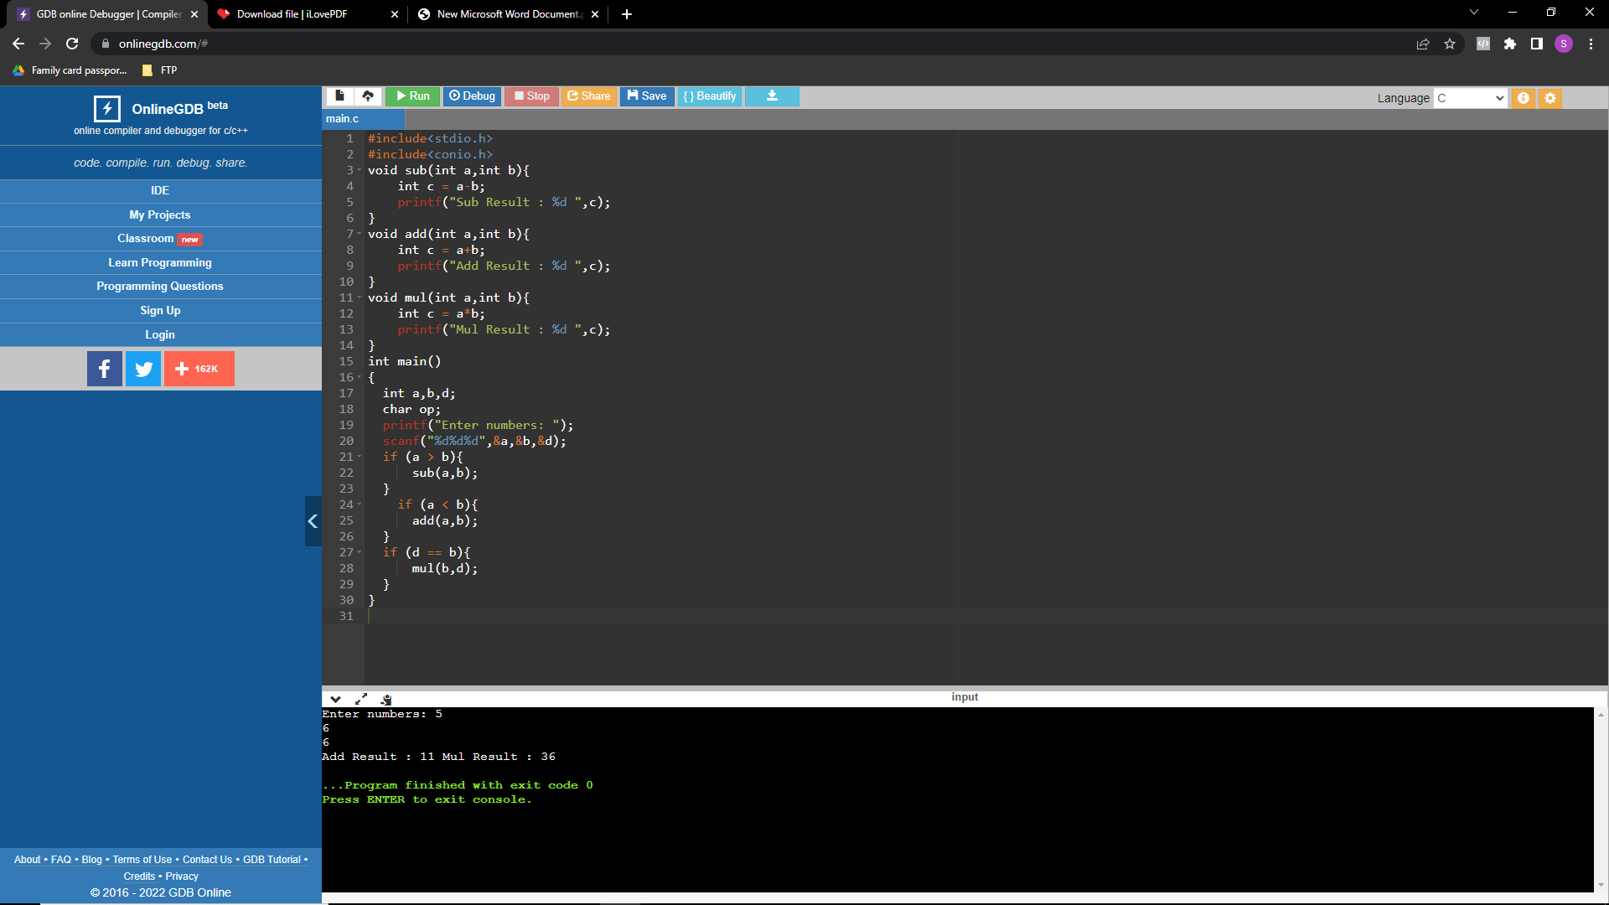

**Answer to the Question No 2(b)**

#include <stdio.h>

#include <conio.h>

#include <string.h>

int main(){

char inputString[100], outputArray[100];

int readIndex = 0, writeIndex;

printf("Enter a String \n");

gets(inputString);

while(inputString[readIndex] == ' '){

readIndex++;

}

for(writeIndex = 0;inputString[readIndex] != '\0'; readIndex++){

if(inputString[readIndex]==' ' && inputString[readIndex-1]==' '){

continue;

}

outputArray[writeIndex] = inputString[readIndex];

writeIndex++;

}

outputArray[writeIndex] = '\0';

printf("String without extra spaces\n%s", outputArray);

getch();

return 0;

}

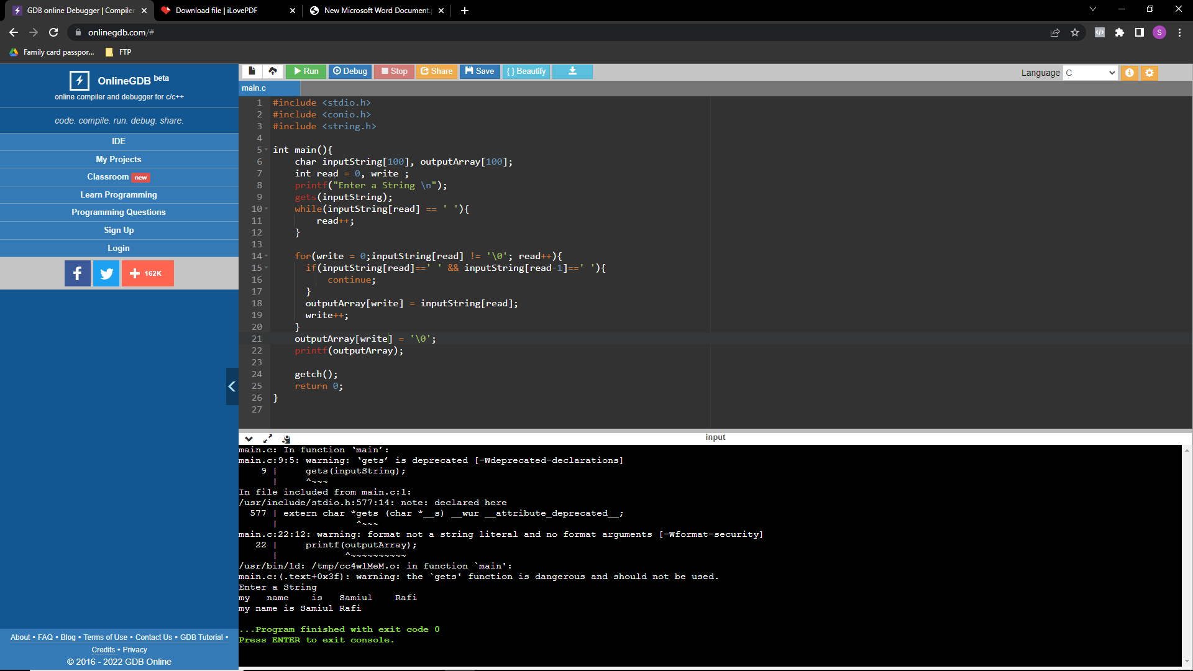

**Answer to the Question No:2(c)**

#include <stdio.h>

#include <string.h>

int main()

{

char password[100];

printf("Enter the password: ");

scanf("%s",password) ;

int upper_case=0, lower_case=0,digit=0,special_char=0;

int length=strlen (password) ;

for (int i=0;i<length;i++)

{

if(password[i]>='A' && password[i]<='Z')

upper_case=1;

if(password[i]>='a' && password[i]<='z')

lower_case=1;

if(password[i]>='0' && password[i]<='9')

digit=1;

if(password[i]=='_' || password[i]=='@' || password[i]=='$' || password[i]=='#')

special_char=1;

}

if(upper_case==0)

printf("Uppercase character missing, ");

if (lower_case==0)

printf("Lowercase character missing, ");

if (digit==0)

printf ("Digit missing, ");

if (special_char==0)

printf("Special character missing");

if (lower_case==1 && upper_case==1 && digit==1 && special_char==1)

printf("OK");

return 0;

}

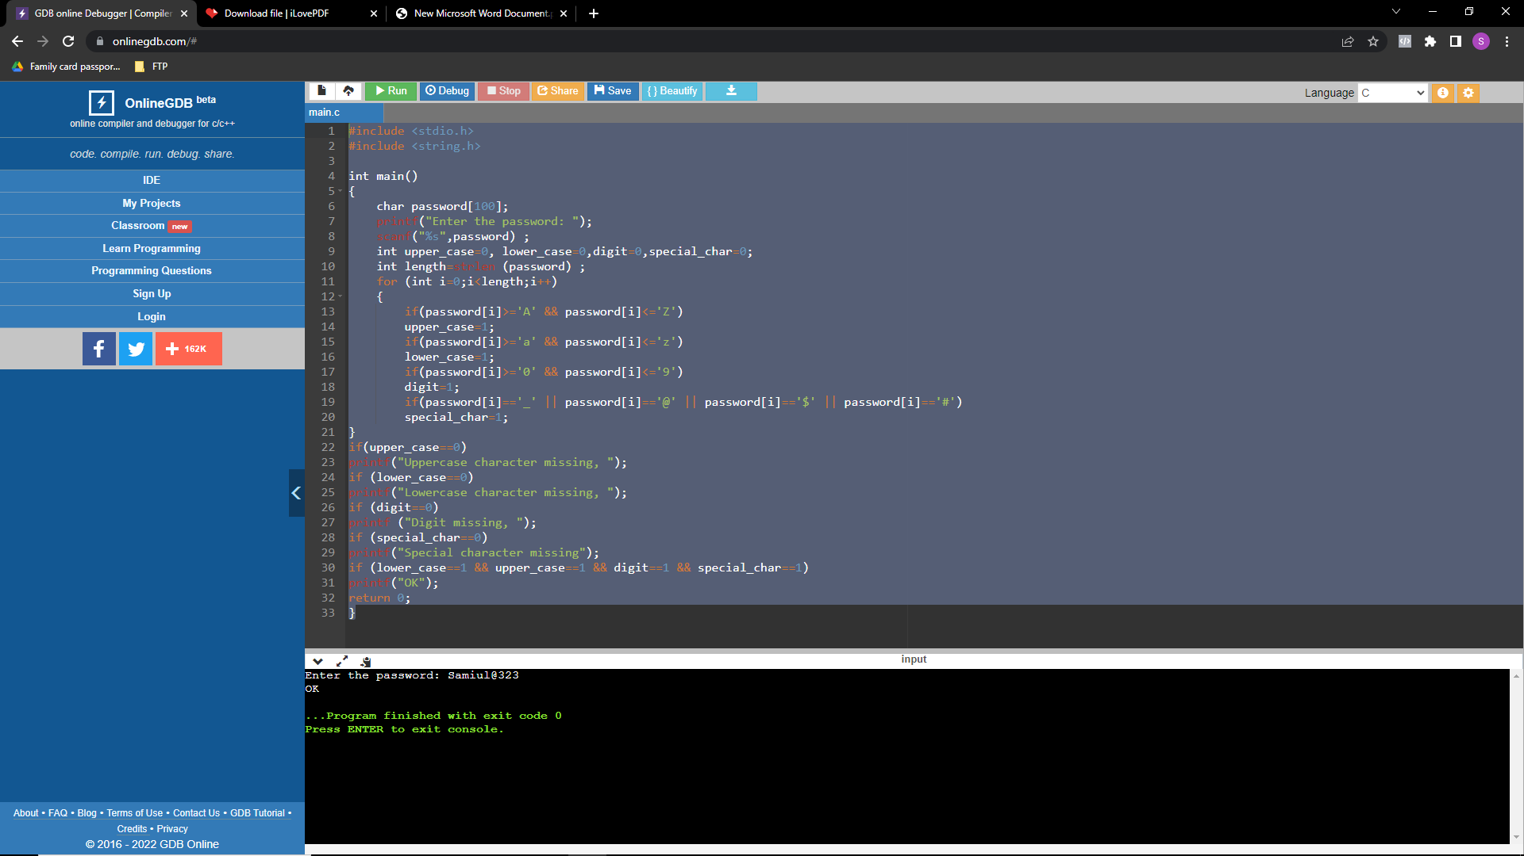

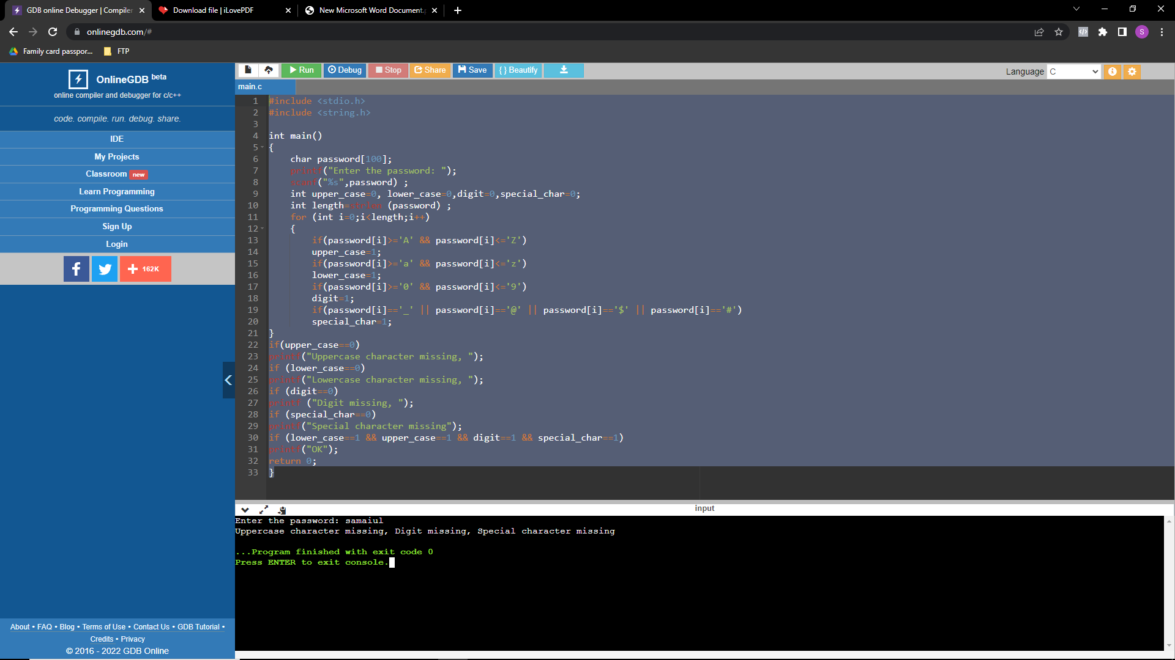

**Answer to the Question No 2(d)**

#include <stdio.h>

void check_email (){

int length = 20;

char email[20];

scanf("%s", &email);

char new_dom [] = "sheba.xyz";

int dom_index = 0;

for(int i=0; i<length; i++){

if(email[i] == '@') {

dom_index = i;

}

}

for (int i = dom_index+1, j=0; j<9; i++,j++){

if(email[i] != new_dom[j]){

printf("Email address is outdated\n");

return;

}

}

printf("Email address is okay\n");

}

int main(){

check_email();

return 0;

}

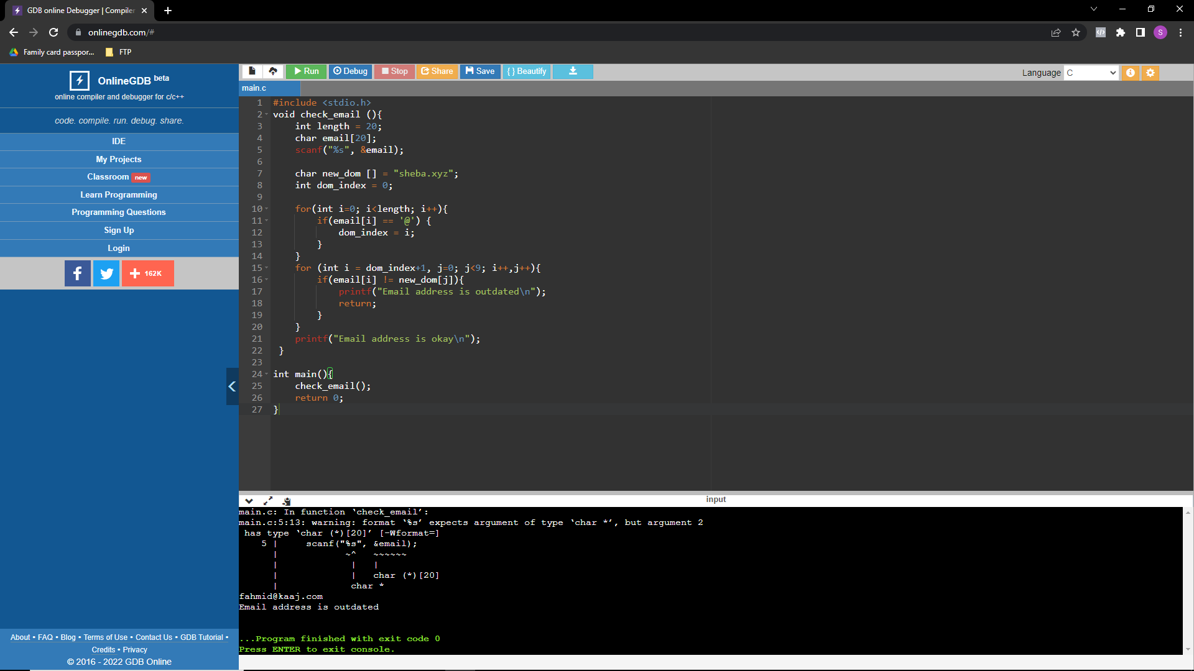

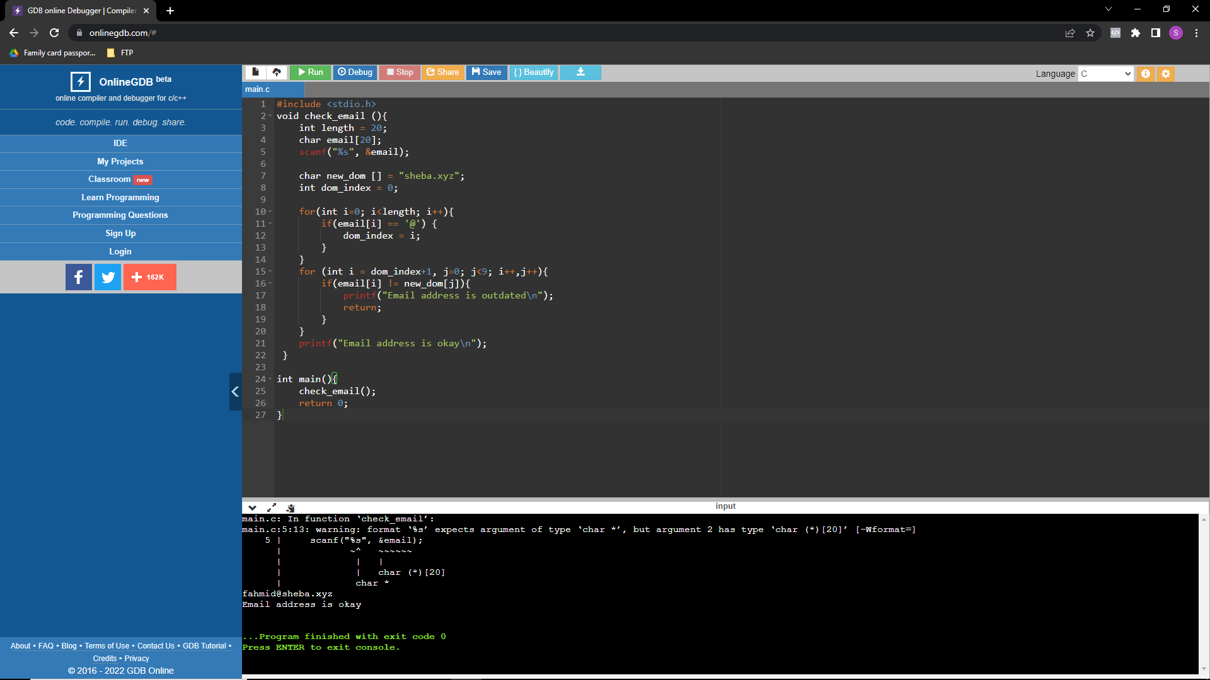

**Answer to The Question No 2(e)**

#include <stdio.h>

#include <string.h>

int main(){

char string1[20];

int i, length;

int flag = 0;

printf("Enter a string:");

scanf("%s", string1);

length = strlen(string1);

for(i=0;i < length ;i++){

if(string1[i] != string1[length-i-1]){

flag = 1;

break;

}

}

if (flag) {

printf("not palindrome");

}

else {

printf("palindrome");

}

return 0;

}

